Documentation for Pi Zero

**MOSTER MOTOR SHIELD**

**References:**

<http://www.instructables.com/id/Monster-Motor-Shield-VNH2SP30/>

<https://pinout.xyz/#>

**Pinout:**

**Pi Zero (BCM) to Motor Shield**

Note: This is using only the pure GPIO pins, might be capable of making it neater using other BCM pins (eg. SPI pins are not used, so could use them).

**NO Level Shifting** is required, 3.3V logic is accepted by the motor shield.

VCC +5V and GND also needs to be connected

|  |  |  |
| --- | --- | --- |
| **Purpose** | **Pi Zero BCM Pin** | **Motor Shield Pin** |
| Motor 0 Enable | 5 | A0 |
| Motor 0 CW | 22 | 7 |
| Motor 0 CCW | 23 | 8 |
| Motor 0 PWM | 12 | 5 |
| Motor 0 Current Sense | Envirophat adc 0 | A2 |
| Motor 1 Enable | 6 | A1 |
| Motor 1 CW | 17 | 4 |
| Motor 1 CCW | 27 | 9 |
| Motor 1 PWM | 13 | 6 |
| Motor 1 Current Sense | Envirophat adc 1 | A3 |

**Current sensing (using EnviroPHAT):**

Connections shown in above table.

The EnviroPHAT uses 3.3V adc logic, so you need to shift the output from the motor shield from 5V to 3.3V. This can be done as the circuit diagram below.

Connect the Enirophat to the 3.3V terminal, Motor Shield current sense to the 5V terminal, and GND to GND.

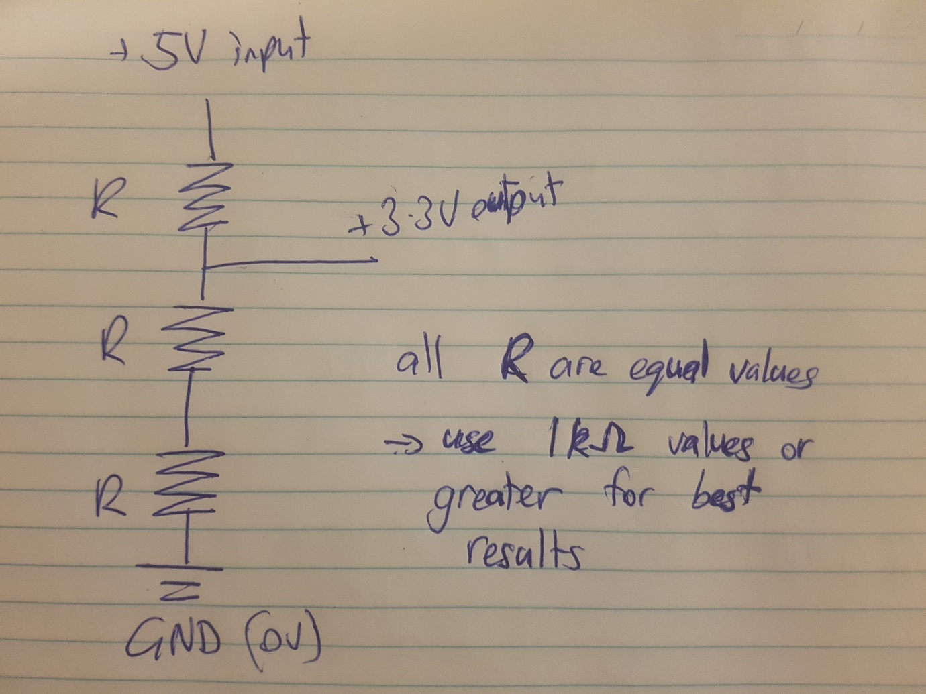

**CAMERA STREAMING**

Camera streaming can be done by using VLC. VLC must be installed on the Pi Zero and receiving computer.

To run camera stream, place ‘cam_stream.sh’ into the pi zero home directory, and can be run in the terminal using: ‘sh cam_stream.sh’.

Configurations for the camera stream (image size, rate, etc) is described in the ‘cam_stream.sh’

On VLC on the host computer, open up Media/Open Network Stream…

Type in:

rtsp://ip-address:8554/

Where ip-address is the IP Address of the pi zero. – eg. 192.168.0.40

Then play.